**Computer vision – Midterm Examination**

Question 1 2

A、 Source code 2

B、 Result map 2

C、 Original file 3

Question 2 4

A、 Source code 4

B、 Analyze 5

C、 Result map 6

Question 3 7

A、 Source code 7

B、 Analyze 9

C、 Result map 11

D、 Original file 12

Appendix(utils.py) 16

|  |  |
| --- | --- |
| Name: | WeiWen Wu |
| Student ID: | 10901007A |

# Question 1

## Source code

|  |
| --- |
| **from** numpy **import** float32**,**ones  **from** utils **import** cv2**,**plot_from_matplotlib  img **=** cv2**.**imread**(**"./Lib2.jpg"**)**  plot **=** plot_from_matplotlib**(**"Question 1(Lib)"**)**  plot**.**col_row **=** **(**2**,**1**)**  kernel **=** ones**((**5**,** 5**),** float32**)/**81  dst **=** cv2**.**filter2D**(**img**,** **-**1**,** kernel**)**  plot**(**"Original"**,**img**)**  plot**(**"Filter2D"**,**dst**)**  plot**.**show**()** |

## Result map

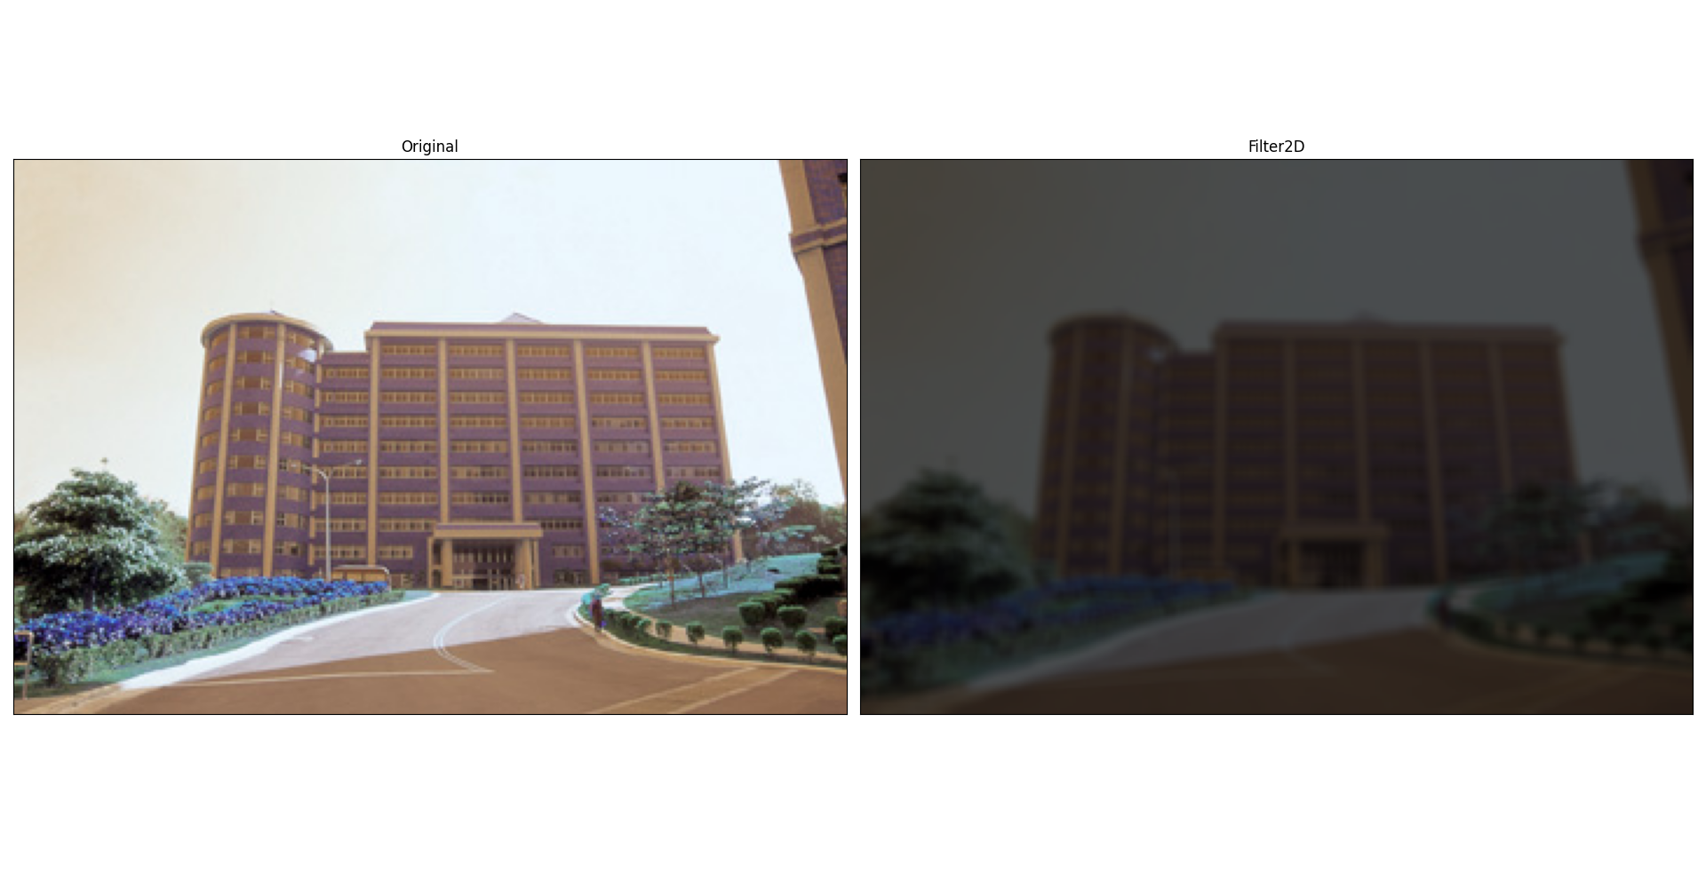

## Original file

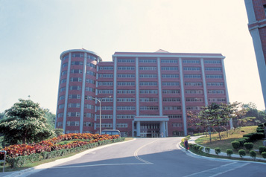

Figure Original

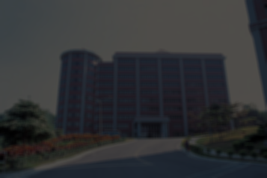

Figure Filter2D

# Question 2

## Source code

|  |
| --- |
| **from** utils **import** cv2**,**plot_from_matplotlib**,**bgr2gray**,**histogram  img **=** bgr2gray**(**"La_Tour_Eiffel_480x700.png"**)**  ### Test threshold ###  # histogram(img).calhist(True)  **def** blur**(**name**:str=**"Question 2(La Tour Eiffel)"**,**threshold**:int=**127**):**  plot **=** plot_from_matplotlib**(**name**)**  plot**.**col_row **=** **(**3**,**2**)**  plot**(**"Original"**,**img**)**  ### Otsu's thresholding ###  _**,**TB **=** cv2**.**threshold**(**img**,**threshold**,**255**,**cv2**.**THRESH_BINARY**)**  plot**(**"thresholding"**,**TB**)**  ### Otsu's thresholding ###  _**,**OTSU **=** cv2**.**threshold**(**img**,**threshold**,**255**,**cv2**.**THRESH_BINARY**+**cv2**.**THRESH_OTSU**)**  plot**(**"Otsu's thresholding"**,**OTSU**)**  ### Otsu's thresholding (Gaussian) ### Otsu's thresholding after Gaussian filtering  blur **=** cv2**.**GaussianBlur**(**img**,(**5**,**5**),**0**)**  _**,**OTSUG **=** cv2**.**threshold**(**blur**,**threshold**,**255**,**cv2**.**THRESH_BINARY**+**cv2**.**THRESH_OTSU**)**  plot**(**"Otsu's thresholding (Gaussian)"**,**OTSUG**)**  ### ADAPTIVE_THRESH_MEAN_C ###  ATMC **=** cv2**.**adaptiveThreshold**(**blur**,**threshold**,**cv2**.**ADAPTIVE_THRESH_MEAN_C**,**cv2**.**THRESH_BINARY**,**11**,**2**)**  plot**(**"ADAPTIVE_THRESH_MEAN_C"**,**ATMC**)**  ### ADAPTIVE_THRESH_GAUSSIAN_C ###  ATGC **=** cv2**.**adaptiveThreshold**(**blur**,**threshold**,**cv2**.**ADAPTIVE_THRESH_GAUSSIAN_C**,**cv2**.**THRESH_BINARY**,**11**,**2**)**  plot**(**"ADAPTIVE_THRESH_GAUSSIAN_C"**,**ATGC**)**  blur**(**"threshold(127)"**,**127**)**  blur**(**"threshold(175)"**,**175**)**  plot_from_matplotlib**.**show**()** |

## Analyze

使用柱狀圖中2個波峰之間的波谷灰階值當門檻值，如Figure 3所示。

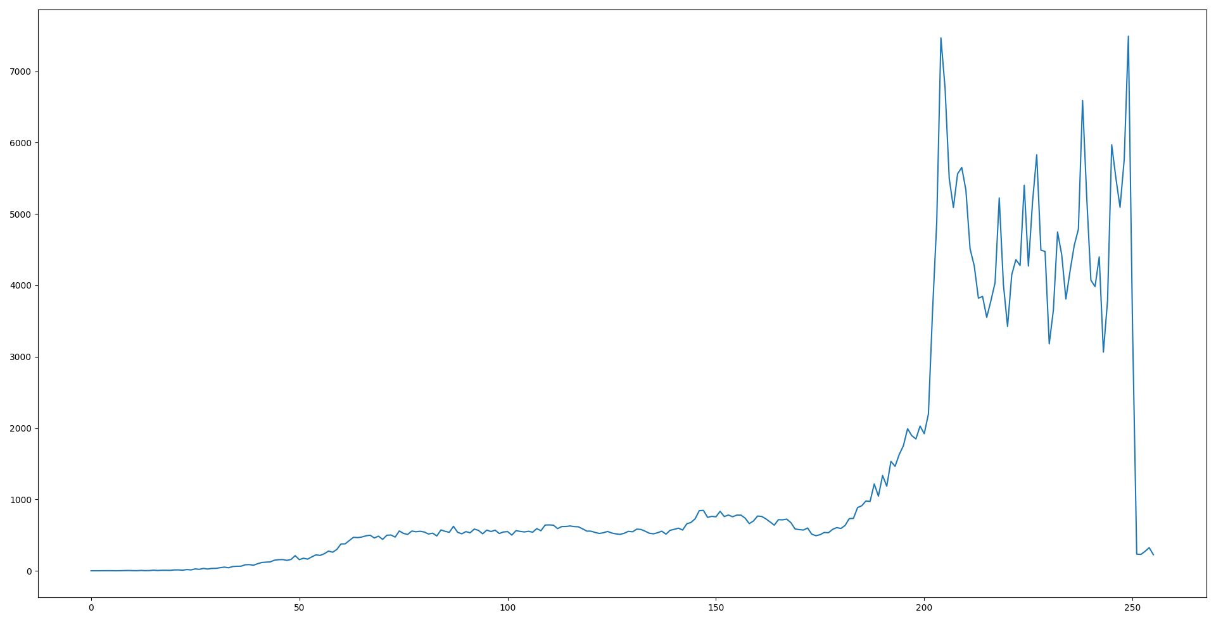

Figure Histogram

## Result map

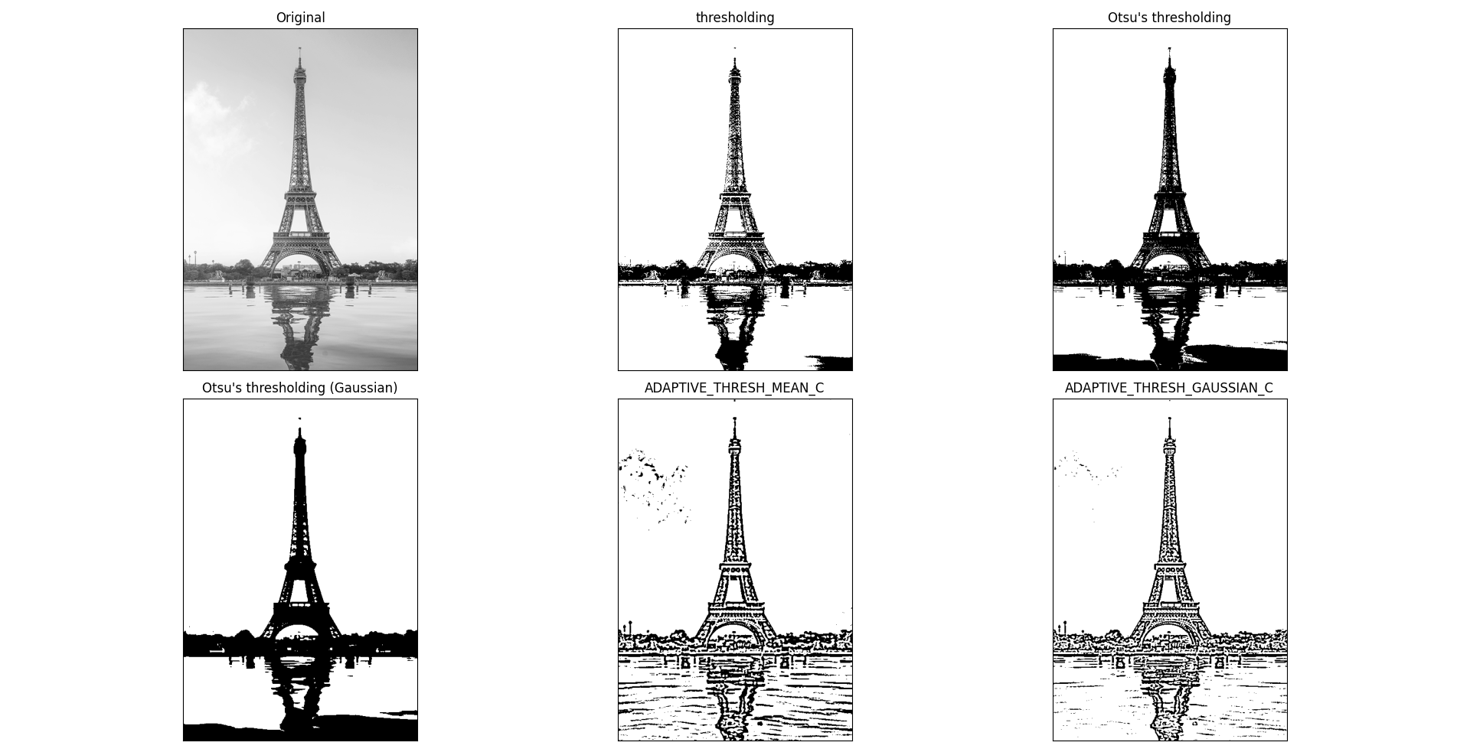

Figure threshold(127)

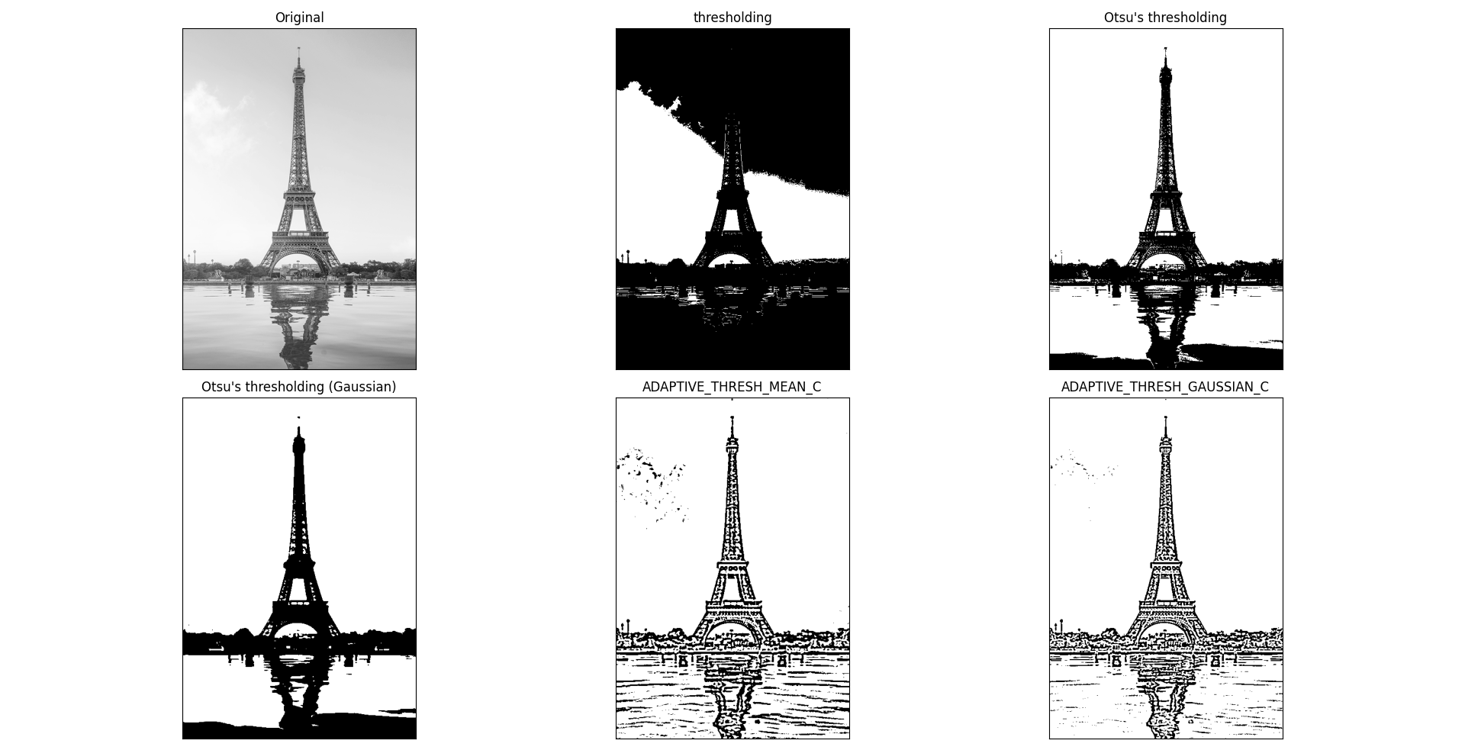

Figure threshold(229)

# Question 3

## Source code

|  |
| --- |
| **from** utils **import** cv2**,**plot_from_matplotlib**,**canny**,**histogram**,**ndarray**,**bgr2gray**,**medianBlur**,**GaussianBlur**,**Optional**,**canny_edge  **def** remove_noise**(**name**:str,**img**:**ndarray**,**canny_arg**:**Optional**[tuple[int,int]]=None):**  """Test to use medianBlur or GaussianBlur."""  **if** canny_arg **==** **None:**  plot_rn **=** plot_from_matplotlib**(**name**)**  plot_rn**.**col_row **=** **(**2**,**2**)**  plot_rn**.**save **=** **False**  ### Median Filtering ###  img_medianBlur **=** medianBlur**(**img**)**  img_medianBlur **=** canny**(**img_medianBlur**)**  plot_rn**(**"Median Filtering"**,**img_medianBlur**)**  ### GaussianBlur ###  img_GaussianBlur **=** GaussianBlur**(**img**)**  img_GaussianBlur **=** canny**(**img_GaussianBlur**)**  plot_rn**(**"GaussianBlur"**,**img_GaussianBlur**)**  ### histogram ###  img_hist **=** histogram**(**bgr2gray**(**img**)).**equalization**()**  plot_rn**(**"histogram"**,**img_hist**)**  ### canny ###  img_canny **=** canny**(**img**)**  plot_rn**(**"canny"**,**img_canny**)**  plot_rn**.**show**()**  **return** img_canny  **else:** **return** canny**(**img**,**canny_arg**[**0**],**canny_arg**[**1**])**  **def** Eiffel_night**()** **->** ndarray**:**  """Eiffel_night"""  night **=** cv2**.**imread**(**"Eiffel_night.jpg"**)**  night **=** GaussianBlur**(**night**)**  night **=** GaussianBlur**(**night**)**  night **=** GaussianBlur**(**night**)**  # canny_edge(night) # 89 255  night**=**remove_noise**(**"night"**,**night**,(**89**,**255**))**  **return** night  **def** Eiffel_night_sp_noise**()** **->** ndarray**:**  """Eiffel_night_sp_noise"""  night_noise **=** cv2**.**imread**(**"Eiffel_night_sp_noise.jpg"**)**  night_noise **=** medianBlur**(**night_noise**)**  night_noise **=** GaussianBlur**(**night_noise**)**  night_noise **=** GaussianBlur**(**night_noise**)**  # canny_edge(night_noise)#75 244  night_noise **=** remove_noise**(**"night_noise"**,**night_noise**,(**75**,**244**))**  **return** night_noise  **def** Eiffel_night_gaussian_noise**(**show**:bool=False)** **->** ndarray**:**  """Eiffel_night_gaussian_noise"""  night_gnoise **=** cv2**.**imread**(**"Eiffel_night_gaussian_noise.jpg"**)**  night_gnoise1 **=** GaussianBlur**(**night_gnoise**)**  night_gnoise2 **=** GaussianBlur**(**night_gnoise1**)**  night_gnoise3 **=** GaussianBlur**(**night_gnoise2**)**  night_gnoise4 **=** medianBlur**(**night_gnoise3**)**  # canny_edge(night_gnoise)#35 252  night_gnoise5 **=** remove_noise**(**"night_gnoise"**,**night_gnoise4**,(**35**,**252**))**  **if** show**:**  plot **=** plot_from_matplotlib**(**"Eiffel_night_gaussian_noise"**)**  plot**.**col_row **=** **(**3**,**2**)**  plot**(**"Original"**,**canny**(**night_gnoise**))**  plot**(**"1. GaussianBlur"**,**canny**(**night_gnoise1**))**  plot**(**"2. GaussianBlur"**,**canny**(**night_gnoise2**))**  plot**(**"3. GaussianBlur"**,**canny**(**night_gnoise3**))**  plot**(**"4. MedianBlur"**,**canny**(**night_gnoise4**))**  plot**(**"5. Result "**,**night_gnoise5**)**  **return** night_gnoise5  **def** Eiffel_night_gaussian_sp_noise**(**show**:bool=False)** **->** ndarray**:**  """Eiffel_night_gaussian_sp_noise"""  night_gnoise_sp **=** cv2**.**imread**(**"Eiffel_night_gaussian_sp_noise.jpg"**)**  night_gnoise_sp1 **=** medianBlur**(**night_gnoise_sp**)**  night_gnoise_sp2 **=** GaussianBlur**(**night_gnoise_sp1**)**  night_gnoise_sp3 **=** GaussianBlur**(**night_gnoise_sp2**)**  # canny_edge(night_gnoise_sp3)#69 255  night_gnoise_sp4 **=** remove_noise**(**"night_gnoise_sp"**,**night_gnoise_sp3**,(**69**,**255**))**  **if** show**:**  plot **=** plot_from_matplotlib**(**"Eiffel_night_gaussian_sp_noise"**)**  plot**.**col_row **=** **(**2**,**2**)**  plot**(**"Original"**,**canny**(**night_gnoise_sp**))**  plot**(**"1. medianBlur"**,**canny**(**night_gnoise_sp1**))**  plot**(**"2. GaussianBlur"**,**canny**(**night_gnoise_sp2**))**  plot**(**"3. GaussianBlur"**,**canny**(**night_gnoise_sp3**))**  # plot("night_gnoise_sp4",canny(night_gnoise_sp3))  **return** night_gnoise_sp4  plot **=** plot_from_matplotlib**(**"Question 3"**)**  plot**.**col_row **=** **(**2**,**2**)**  plot**.**save**=**0  plot**(**"Eiffel_night"**,**Eiffel_night**())**  plot**(**"Eiffel_night_sp_noise"**,**Eiffel_night_sp_noise**())**  plot**(**"Eiffel_night_gaussian_noise"**,**Eiffel_night_gaussian_noise**())**  plot**(**"Eiffel_night_gaussian_sp_noise"**,**Eiffel_night_gaussian_sp_noise**())**  plot_from_matplotlib**.**show**()** |

## Analyze

使用remove_noise函數，測試medianBlur或GaussianBlur，哪一個方法較好，如Figure 6所示。最後使用canny_edge函數決定Canny 上限和下限值，如Figure 7所示。

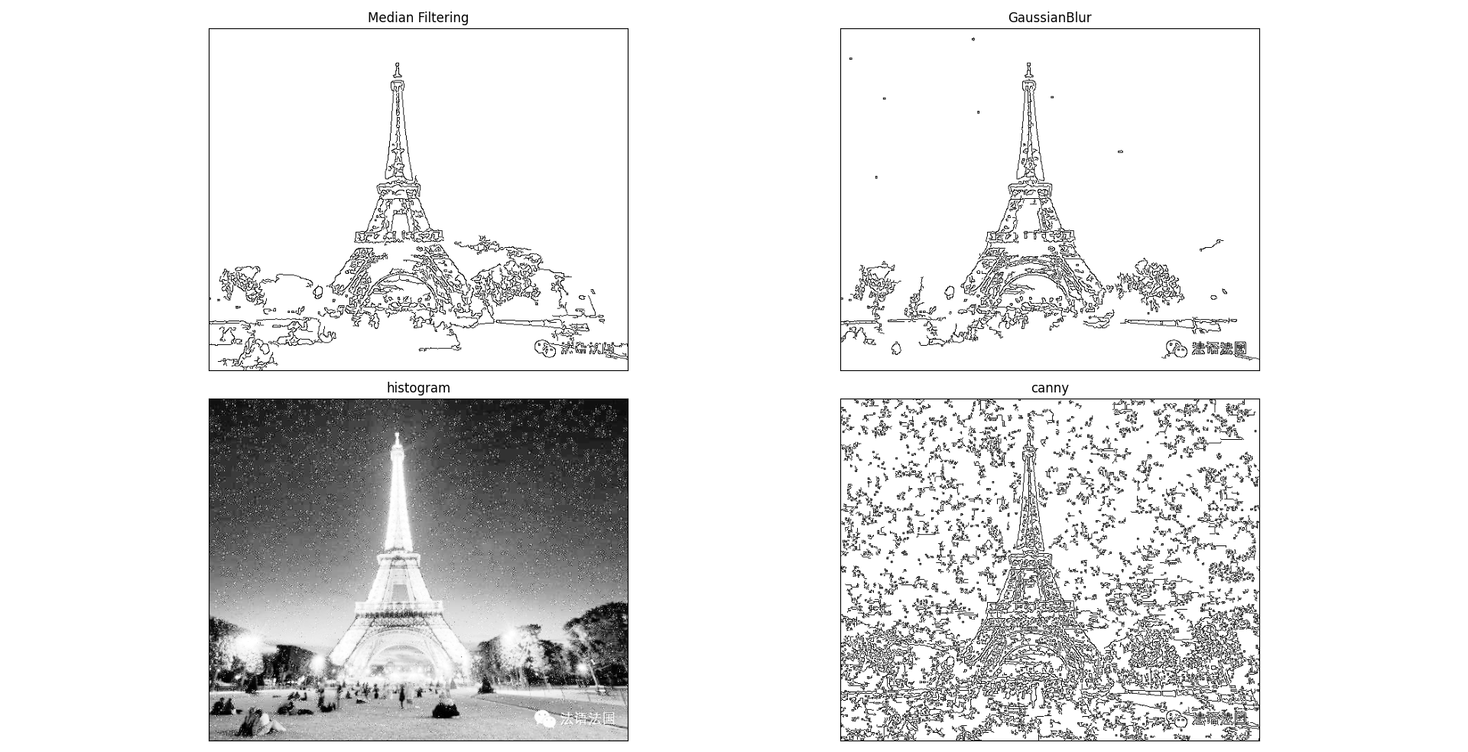

Figure Test to use medianBlur or GaussianBlur.

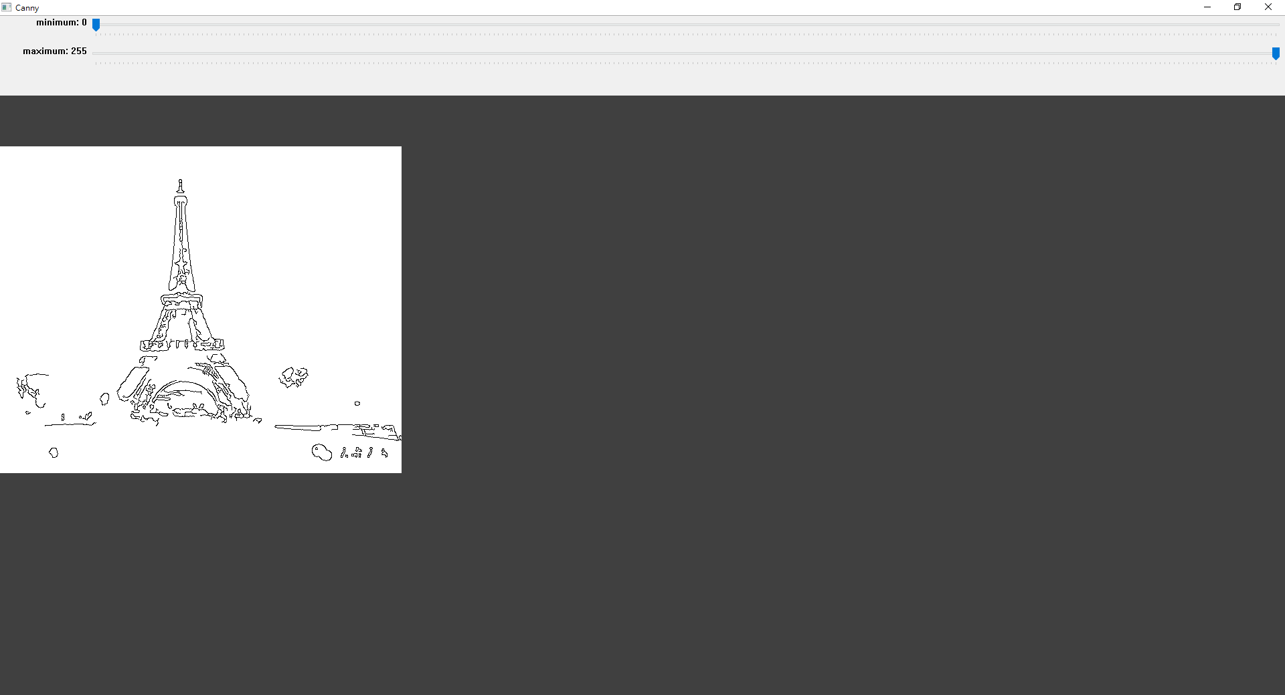

Figure Test Canny upper and lower values.

## Result map

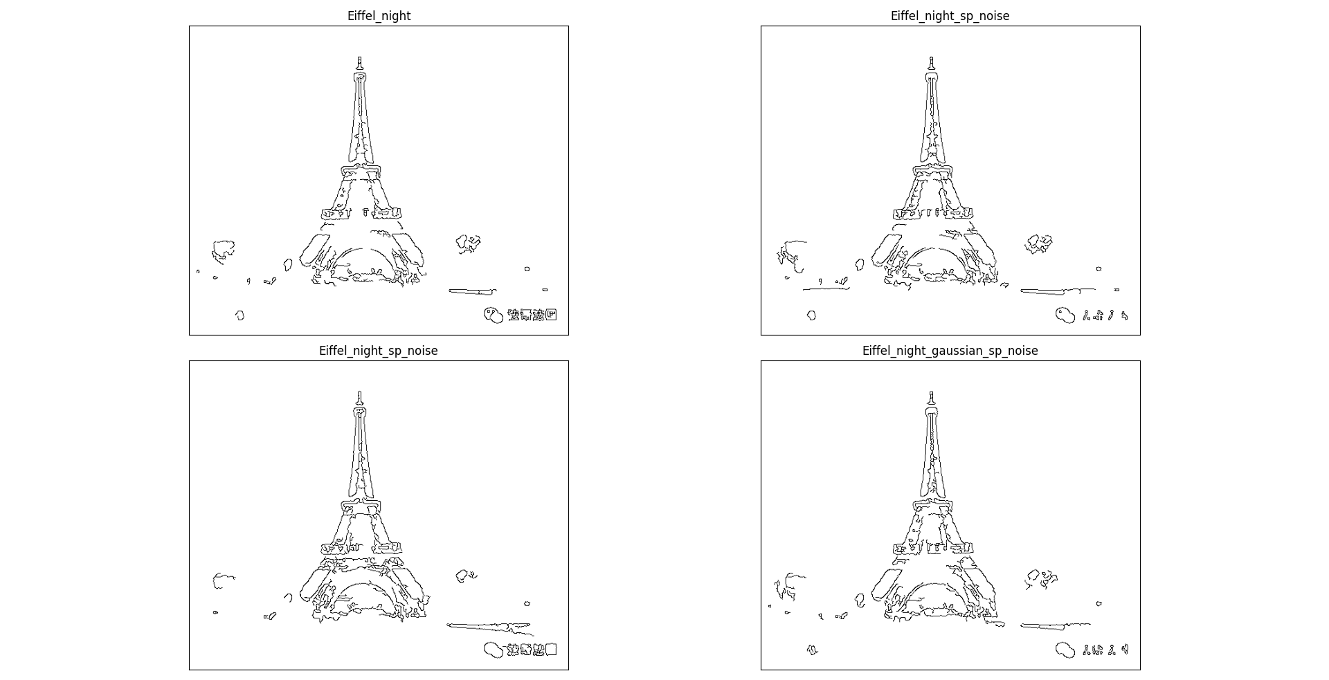

## Original file

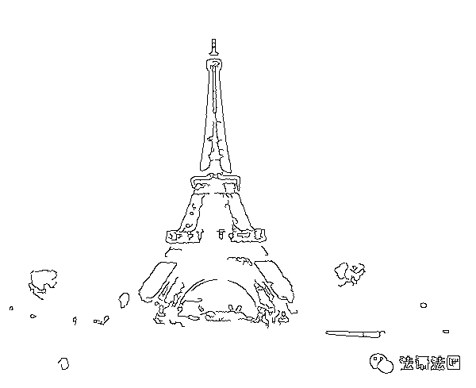

Figure Eiffel_night

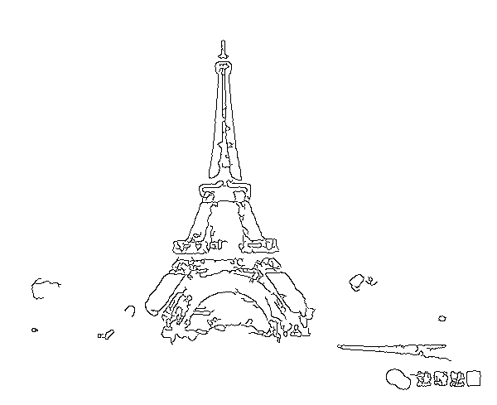

Figure Eiffel_night_gaussian_noise

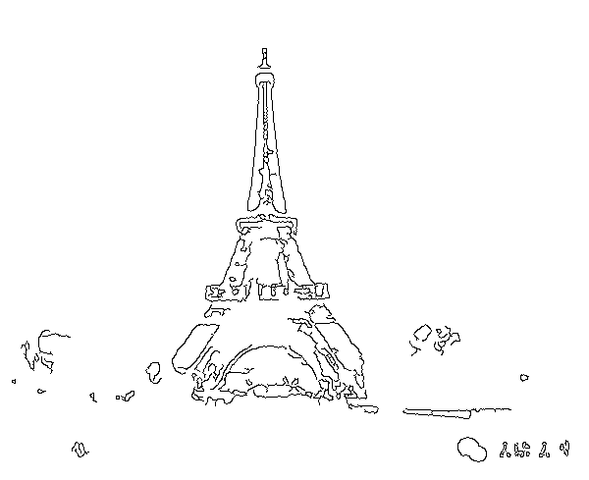

Figure Eiffel_night_gaussian_sp_noise

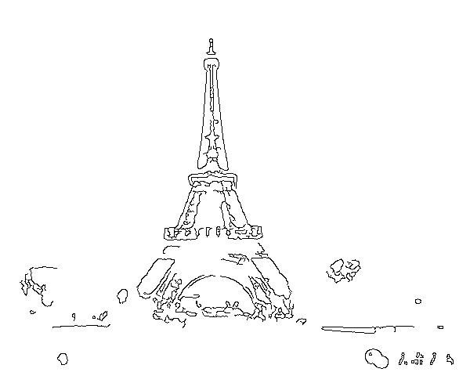

Figure Eiffel_night_sp_noise

# Appendix(utils.py)

|  |
| --- |
| # utils.py WeiWen Wu  **from** matplotlib **import** pyplot **as** plt  **import** cv2  **from** typing **import** Literal**,**Union**,**Optional  **from** numpy **import** ndarray  **class** **plot_from_matplotlib:**  """  Make pictures from matplotlib.  # Example  ```  plot = plot_from_matplotlib("title")  plot.col_row = (2,2)  plot.save = True  plot("Original",img)  plot_from_matplotlib.show()  ```  """  n**:int=**1  col_row**:tuple[int,int]**  save**:bool=False**  **def** __init__**(**self**,**name**:str)** **->** **None:**  fig **=** plt**.**figure**()**  fig**.**canvas**.**manager**.**window**.**setWindowTitle**(**name**)**  fig**.**tight_layout**()**  # fig.subplots_adjust(top=0.95, bottom=0.05, left=0.0, right=1.0)  self**.**fig **=** fig  **def** __call__**(**self**,**name**:str,**dst**,**cmap**:str=**'gray'**,**save**:bool=**0**):** # Make pictures.  n **=** self**.**n  col**,**row **=** self**.**col_row  path **=** __file__**.**split**(**"\\"**)[-**2**]**  plt**.**subplot**(**row**,**col**,**n**),** plt**.**imshow**(**dst**,**cmap**),** plt**.**title**(**name**)**  plt**.**xticks**([]),** plt**.**yticks**([])** # Do not show scale.  **if** save **or** self**.**save**:** cv2**.**imwrite**(**f"./{path}/{name}.png"**,**dst**,[int(**cv2**.**IMWRITE_PNG_COMPRESSION**),**0**])**  self**.**n**+=**1  # @staticmethod  **def** show**(**self**):**  """Display image."""  self**.**fig**.**tight_layout**()**  plt**.**show**()**    *@staticmethod*  **def** show**():**  """Display image."""  plt**.**show**()**  **class** **histogram:**  """  Imgage Histogram - Find, Plot and Analyze  It which gives you an overall idea about the intensity distribution of an image.  It distribute data along x and y axis.  x - axis contain range of color vlaues.  y - axis contain numbers of pixels in an image.  With histogram to extrct information about contast, brigthness and intensity etc.  plot histomgram using matplotlib  # Example  ```  hist = histogram()  histogram.plot(hist.calhist())  imshow("hist",hist.equalization())  ```  """  **def** __init__**(**self**,**img**:**Union**[str,**ndarray**]=**"lena.jpg"**)** **->** **None:**  **if** **isinstance(**img**,str):**  img **=** cv2**.**imread**(**img**)**  img **=** bgr2gray**(**img**)**  self**.**img **=** img    # img = cv2.resize(img,(500,650))    *@staticmethod*  **def** plot**(**img**:**ndarray**):**  fig **=** plt**.**figure**()**  fig**.**canvas**.**manager**.**window**.**setWindowTitle**(**"Histogram"**)**  plt**.**plot**(**img**)**  plt**.**show**()**  **def** calhist**(**self**,**show_hist**:bool=False)** **->** ndarray**:**  """Plotting with calhist method."""  # It accept parameters like ([img],[channel],mask,[histsize],range[0-255]).  hist **=** cv2**.**calcHist**([**self**.**img**],** **[**0**],** **None,** **[**256**],** **[**0**,** 256**])**  **if** show_hist**:** histogram**.**plot**(**hist**)**  **return** hist  **def** plot_bgr_hist**(**self**):**  b**,** g**,** r **=** cv2**.**split**(**self**.**img**)**  #cv2.imshow("img", img)  # cv2.imshow("b", b)  # cv2.imshow("g", g)  # cv2.imshow("r", r)  #Plotting different channel with hist  plt**.**hist**(**b**.**ravel**(),** 256**,** **[**0**,** 256**])**  plt**.**hist**(**g**.**ravel**(),** 256**,** **[**0**,** 256**])**  plt**.**hist**(**r**.**ravel**(),** 256**,** **[**0**,** 256**])**  plt**.**title**(**"ColorFull Image"**)**  plt**.**show**()**  **def** equalization**(**self**)** **->** ndarray**:**  """Histogram equalization is good when of the image is confined to a particular region."""  img_gray **=** self**.**img  equ **=** cv2**.**equalizeHist**(**img_gray**)**  # res = hstack((img_gray,equ)) #stacking images side-by-side  **return** equ  **def** imshow**(**title**:str,**img**:**ndarray**):**  """Show image."""  cv2**.**imshow**(**title**,**img**)**  cv2**.**waitKey**(**0**)**  cv2**.**destroyAllWindows**()**  **def** bgr2gray**(**img**:**Union**[str,**ndarray**],**blur**:bool=False)** **->** ndarray**:**  """Convert bgr to gray and remove noise points."""  **if** **isinstance(**img**,str):**img **=** cv2**.**imread**(**img**)** # Read image.    **if** blur**:**  img **=** cv2**.**GaussianBlur**(**img**,** **(**3**,** 3**),**0**)** # GaussianBlur  img **=** cv2**.**medianBlur**(**img**,** 3**)** # Median Filtering  img **=** cv2**.**GaussianBlur**(**img**,** **(**3**,** 3**),**0**)** # GaussianBlur  img **=** cv2**.**medianBlur**(**img**,** 3**)** # Median Filtering  **return** cv2**.**cvtColor**(**img**,**cv2**.**COLOR_BGR2GRAY**)** # BGR to gray.  **def** plot_histogram**(**img**:**ndarray**)** **->** **None:**  """Plot histogram."""  fig **=** plt**.**figure**()**  fig**.**canvas**.**manager**.**window**.**setWindowTitle**(**"Histogram"**)**  hist **=** cv2**.**calcHist**([**img**],** **[**0**],** **None,** **[**256**],** **[**0**,** 256**])**  plt**.**plot**(**hist**)**  plt**.**show**()**  **def** canny**(**img**:**ndarray**,min:int=**0**,max:int=**255**)** **->** ndarray**:**  """cv2.Canny (input gray)"""  **return** cv2**.**bitwise_not**(**cv2**.**Canny**(**bgr2gray**(**img**),min,max))**    **def** canny_edge**(**img**:**ndarray**)** **->** **tuple[int,int]:**  """Test Canny upper and lower values."""  cv2**.**namedWindow**(**"Canny"**)**  ### Create a track bar ### cv2.createTrackbar('Slider name', 'window name', min, max, fn)  cv2**.**createTrackbar**(**"minimum"**,** "Canny"**,** 0**,** 255**,** **lambda** _**:**_**)**  cv2**.**createTrackbar**(**"maximum"**,** "Canny"**,** 0**,** 255**,** **lambda** _**:**_**)**  cv2**.**setTrackbarPos**(**"minimum"**,** "Canny"**,** 0**)**  cv2**.**setTrackbarPos**(**"maximum"**,** "Canny"**,** 255**)**    img **=** bgr2gray**(**img**)**  **while** **True:**  ### Get trackbar position. ### cv2.setTrackbarPos('Slider name', 'window name', default)  **min=** cv2**.**getTrackbarPos**(**'minimum'**,**'Canny'**)**  **max=** cv2**.**getTrackbarPos**(**'maximum'**,**'Canny'**)**    cv2**.**imshow**(**"Canny"**,**canny**(**img**,min,max))**  key **=** cv2**.**waitKey**(**1**)**  **if** key **==** **ord(**'q'**)** **or** key **==** 27**:**  **break**  cv2**.**destroyAllWindows**()**  **return** **min,max**  **def** medianBlur**(**img**)** **->** ndarray**:return** cv2**.**medianBlur**(**img**,** 3**)**  **def** GaussianBlur**(**img**)** **->** ndarray**:** **return** cv2**.**GaussianBlur**(**img**,** **(**3**,** 3**),**0**)** |